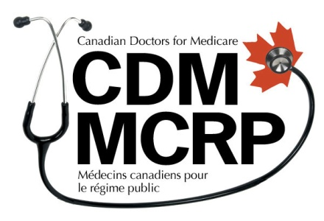
Canadian Doctors for Medicare
Médecins canadiens pour le régime public

14 September 2015

Canadians support Quebec’s opposition to extra-billing for health services proposed in amendment to Bill 20, which would create a two-tier system with barriers for low-income people.

Canadians across the country have expressed their support for Quebec groups opposing Minister Barrette's proposed amendment to Bill 20, which is aimed at legalizing extra billing.

“The extra billing Minister Barrette's proposes in his amendment to Bill 20 will create a two-tier health-care system that limits care for people who can't afford extra fees. This dangerous precedent would violate the Canada Health Act and jeopardize universal access to health care in every province. Doctors across Canada stand with Quebec organizations in defense of universal health care,” said Ryan Mieli, Acting Chair of Canadian Doctors for Medicare.

As amended, the Bill would enable the government to allow currently illegal fees to be added to health care services by simple regulation, with no clearly established limits. These fees can be charged during medical office visits, for facilities, services, supplies, equipment, or tests that are associated with an insured service.

User fees are prohibited under the Canada Health Act. Provinces that allow it are subject to sanction in the form of withholding of federal transfers in the amount equal to the fees. Health Canada confirmed in June that the costs related to the provision of insured medical services are user fees, or extra billing, and that the law prohibits such fees, which effectively create a two-tier health care system.

Research shows that mandatory fees are an impediment to care, especially for low income people who often don’t access care until they are so sick they can’t avoid it, which not only damages their quality of life, but makes them more expensive to treat.

“The Quebec government’s proposed amendment to Bill 20 would erode one of the core principles of medicare, that health care should be based on need and not ability to pay. The extra-billing proposed in Bill 20 is not only unjustifiable, but creates a slippery slope to two-tiered, US style health care where patients suffer. This is not the health that Quebecers expect or deserve,” said Michael Butler, Nation Health Campaigner, Council of Canadians.

"We are hoping that the people of Quebec will support their doctors who are trying to protect patients against user fees and extra-billing in health care. In Ontario, public outcry has worked to successfully push back extra-billing by private clinics, and our government has shown that wait times can be improved by improved investment in local public hospitals that provide equal care for all. But the more that private clinics and two tier health care spread in our neighbouring provinces, the more of a threat we face here. We hope Quebec will stand up for the fundamental principle that all people should receive timely medical care and that it should be provided on an equal basis, not based on wealth and certainly not subject to extra user fees for patients in need,” said Natalie Mahra, Executive Director, Ontario Health Coalition.

-30-

Contacts:

Canadian Doctors for Medicare
Chad Andrews
chad@canadiandoctorsformedicare.ca
416-351-3300

Ontario Health Coalition
Natalie Mehra, Executive Director
ohc@sympatico.ca
416-441-2502

Council of Canadians
Michael Butler, National Health Care Campaigner
mbutler@canadians.org
416-979-5554

Canadian Doctors for Medicare provides a voice for Canadian doctors who want to strengthen and improve Canada's universal publicly-funded health care system. We advocate for innovations in treatment and prevention services that are evidence-based and improve access, quality, equity and sustainability.

Ontario Health Coalition works to protect and improve our public health care system. We work to honour and strengthen the principles of the Canada Health Act. We are led by our shared commitment to core values of equality, democracy, social inclusion and social justice; and by the five principles of the Act: universality; comprehensiveness; portability; accessibility and public administration. We are a non-profit, non-partisan public interest activist coalition and network.

Council of Canadians is Canada’s leading social action organization, mobilizing a network of 60 chapters across the country. Through our campaigns we advocate for clean water, fair trade, green energy, public health care, and a vibrant democracy. We educate and empower people to hold our governments and corporations accountable.

CANADIAN DOCTORS FOR MEDICARE
340 Harbord St., Toronto, ON, M6G 1H4 • 1 (877) 276-4128 • 1 (416) 351-3300 • www.canadiandoctorsformedicare.ca

